The USER MANUAL

The program was developed on MARS PLUS v4.5 in Windows 10. The users need to have a Windows 10 computer with a keyboard and MARS Plus installed.

HOW TO GET THE SOFTWARE: You will need a computer with the internet access.

1. The user needs to access to the internet and get to the link:

<https://courses.missouristate.edu/KenVollmar/mars/download.htm>

(Credit goes by: Missouri State University)

1. Click to *DOWNLOAD MARS* box, version 4.5, August 2014

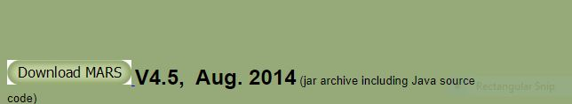

1. 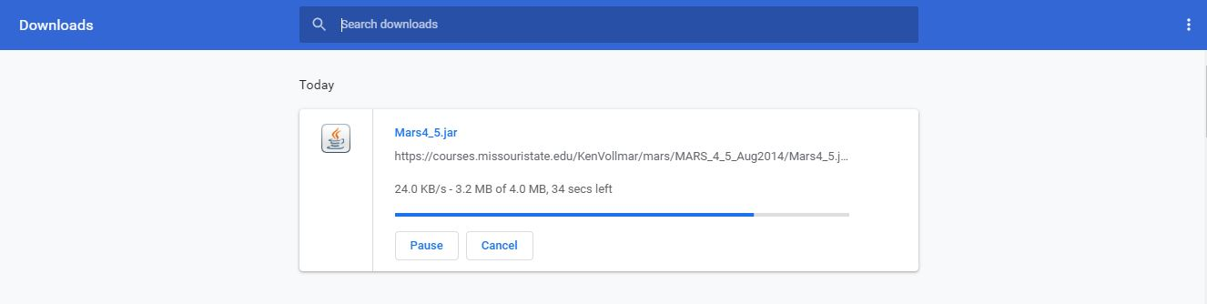
2. Run Mars4_5.jar

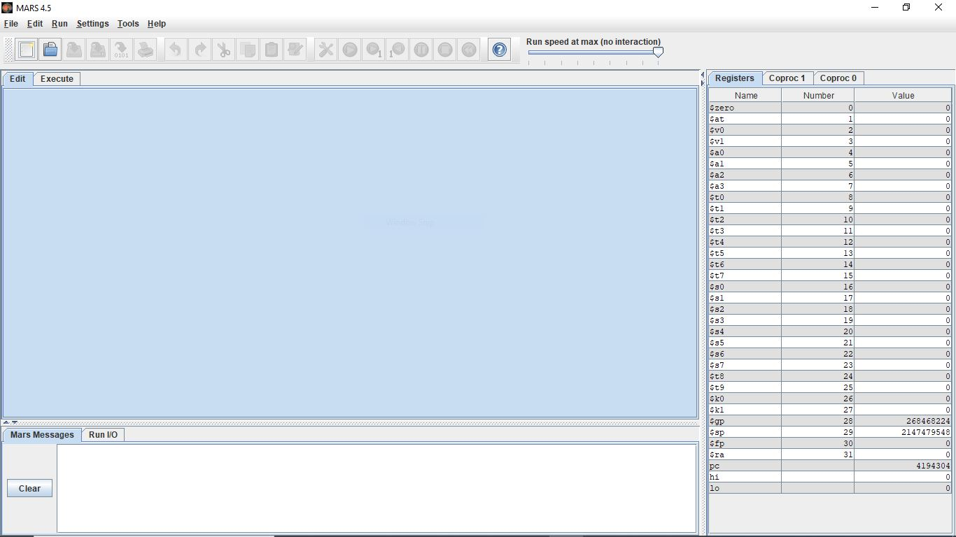

1. Go File/Open

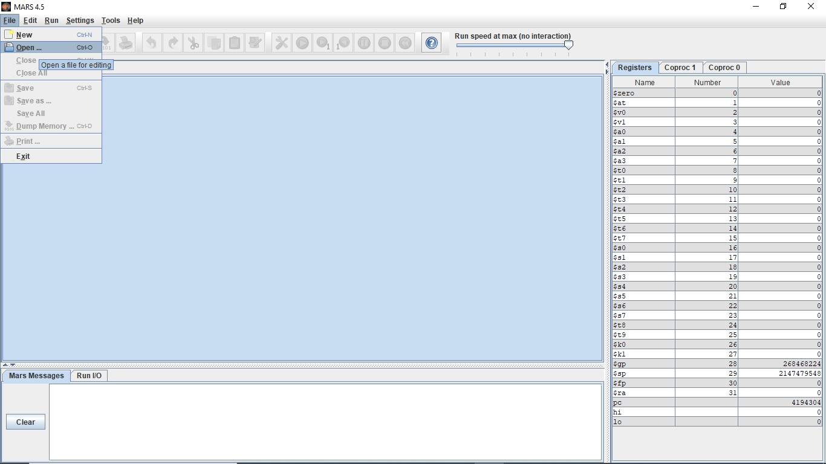

1. Go to the location where you have the mind reader game program. (For example, it can be like : C:\Users\...\Downloads\TheMindReaderGame.asm

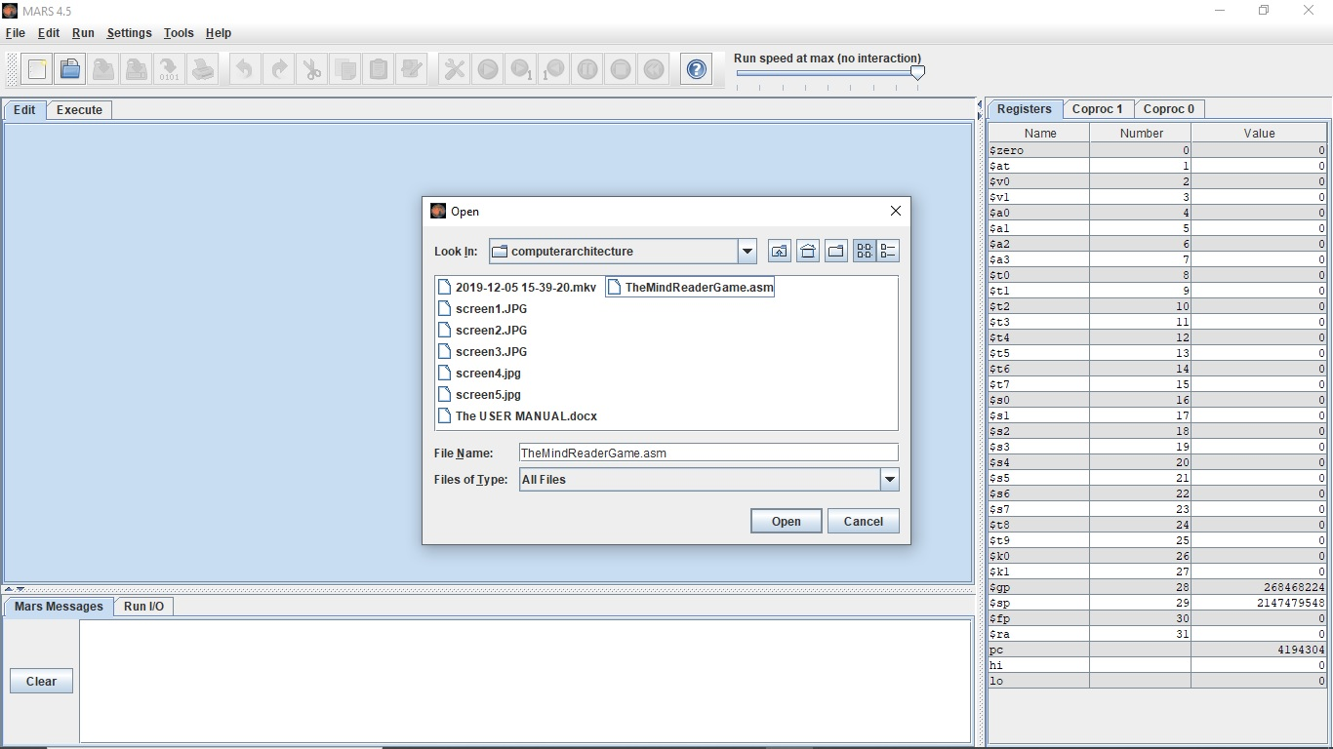

HOW TO RUN THE PROGRAM:

1. Click on Run\Assembly after you open the source file.

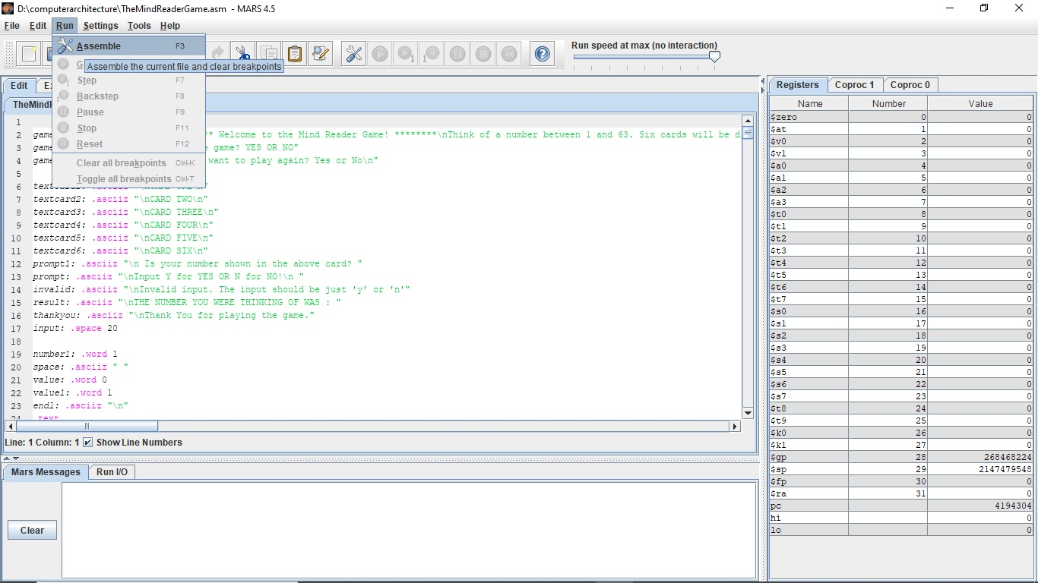

1. Continue click on Run\Go to run the program.

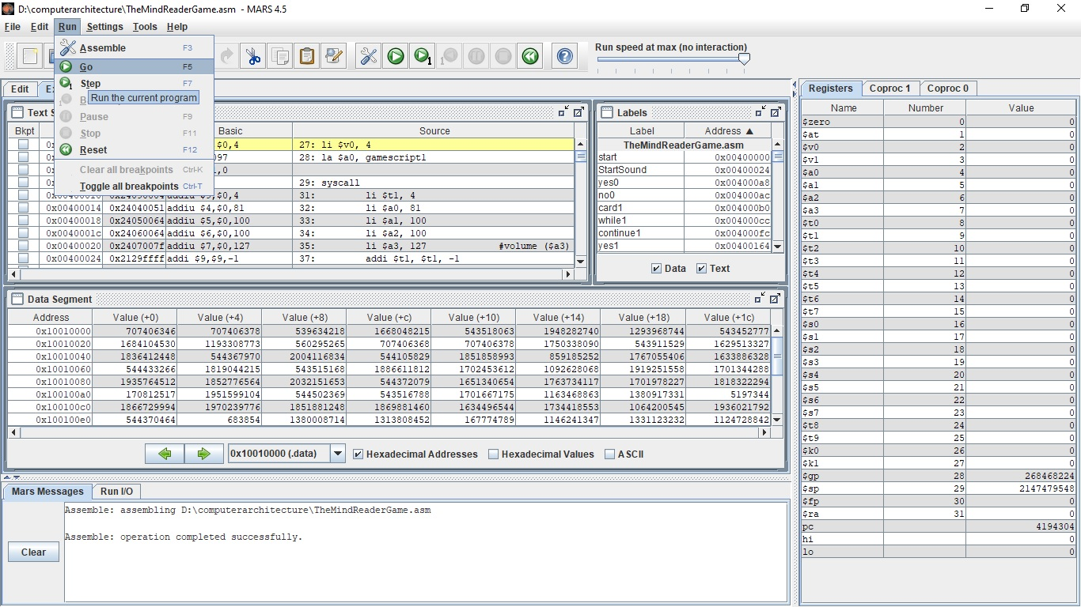

1. The program will ask you some questions on the prompt screen.

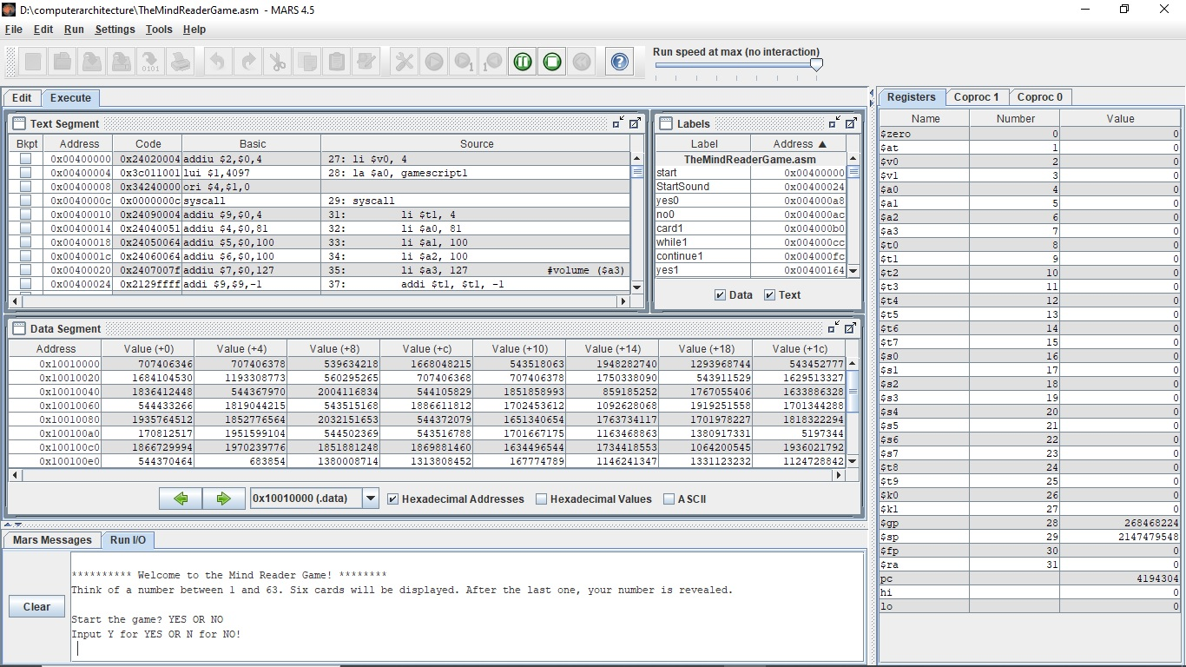

1. Answer them by using ‘y’ or ‘n’ keys on the keyboard of your computer.
2. Have fun!